Anti-Diabetic Activity and Anti-Oxidant Activity of Kalanchoe Pinnata and their Characterization Studies.

Parvathy Menon P R¹,*Nirmala Devi N², *R Ragunathan³, *Jesteena Johney⁴

^{1*}Department of Biochemistry, Sree Narayana Guru College, KG Chavadi, Coimbatore, Tamil Nadu-641105, India
² Associate Professor and Head of the Department of Biochemistry, Sree Narayana Guru College, KG Chavadi, Coimbatore, Tamil Nadu-641105, India
³Director and Research Supervisor, Centre for Bioscience and Nano science Research (CBNR), Tamil Nadu-641021, India
⁴Head of the Department, Centre for Bioscience and Nano science Research (CBNR) Tamil Nadu-641021, India

*Corresponding Author: Nirmala Devi N
Associate Professor and Head of the Department of Biochemistry, Sree Narayana Guru College, KG Chavadi, Coimbatore, Tamil Nadu-641105, India

ABSTRACT
Species of Kalanchoe have been used as a remedy for various infectious diseases and cancer treatment. This study evaluates the anti-diabetic properties of the plant, Kalanchoe pinnata. Phytochemical components, anti-oxidant assays were also carried out. Phytochemical analysis showed the presence of alkaloids, flavonoids, steroids, phenolic compounds. The free radical scavenging activity was determined in which the ethanol extract showed the maximum inhibitory effect when compared with aqueous extract .Thin layer chromatography was done to determine the compound in a solvent system of methanol, acetic acid, formic acid and water in the ratio 3:1:1:0.5 . Characterization of the leaf extract was done by UV-visible spectroscopy which showed the peak between 300-350nm. FTIR analysis showed the presence of the various functional group present in the plant. Aqueous and ethanol extract was subjected to α-amylase inhibitory effect and α-glucosidase inhibitory effect to find the antidiabetic potential activity of the plant extract.

Key words: Kalanchoe, Phytochemical, Antidiabetic, TLC, Antioxidant

- INTRODUCTION
Diabetes mellitus is a metabolic disorder that affect the human population of the world, which is characterized by hyperglycemia. Hyperglycemia is a condition of elevated blood sugar level that is arise from the insulin action or secretion. This causes the long term damage to life like organ dysfunction of kidney, heart, blood vessels[1]Major symptoms of diabetes mellitus includes, high level of sugar in blood, frequent urination, increased appetite, extreme weakness, loss of weight , abnormal thirst.[2][3]Diabetes mellitus is classified mainly as Type I diabetes and Type II diabetes.
Type I diabetes is called as Insulin Dependent Diabetes caused by deficiency of Insulin. It is autoimmune disease which causes the destruction of β-cells of pancreas, while Type II disease is more commonly known as Non-Insulin Dependent Diabetes which is due to the ineffective use of insulin in the body. There is another class of diabetes called as Gestational diabetes with the outbreak of pregnancy arise from glucose intolerance. This condition may later develop to long term risk of diabetes[4].
As stated by World Health Organization in 2014, founded that 422 million adults were affected by diabetes out of which majority of population affected by Type II diabetes. It also causes the death rate higher. It was evident that mainly Type II diabetes were discovered among adults but now in children also[5]. Reactive Oxygen species (ROS) known as free radicals and impaired antioxidants have found to be the pathophysiology of the diabetes mellitus. The organic antioxidants work to cease the harmful effect of oxidative stress brought by the free radicals. It was found that the phenolic compounds are primarily responsible for the antioxidant activity[6]. To control the level of sugar apart from the current therapeutics, medicinal plants have been used as a source for the drug.
Medicinal plants have been used as a source of bioactive compounds and they play a major role to eternalize human health. From the ethno botanical information, founded that approximately 800 plants possess antidiabetic potential[7].From the detailed survey and data of the medicinal plants, we strength to ascertain new drugs which is therapeutically active and cheaper. A member of the Crassulaceae, Kalanchoe pinnata have remarkable insulin secretagogue action, which the latent leaves can be used for the treatment of diabetes [8].
Kalanchoe pinnata is traditionally known to exhibit pharmacological activity. The species of Kalanchoe are found in Madagascar and are cultivated as the ornamental plants. It is an herb that grows 0.3 to 1.2 m high. It is a perennial, succulent, short, erect herb with tuberous and glabrous stem. The leaves are simple, opposite, 3-5 lobed, thick, fleshy and blackish with crenate margins.This plant is specially noted for developing small plantlets on the external edges of its leaves, when its leaves are separated[9][10]. In India, Kalanchoe is valued high for its medicinal properties. The leaves are noted to treat burns, ulcer, diarrhea, cholera. Despite being rich in various phytochemicals, it contain a group of chemicals called bufadienolides. They have been responsible for many pharmacological activities of Kalanchoe extracts[11][12]
This study aim to assess the in vitro anti diabetic activity of plant source used in traditional medicine. The extracts prepared were used to assess the antioxidant properties .This helps to identify which could be a therapeutic agent in treatment of disease.

2.0MATERIALS AND METHODS
2.1PLANT MATERIAL COLLECTION AND EXTRACTION
The leaves of Kalanchoe pinnata was collected from the botanical garden of Centre for Bioscience and Nano science Research (CBNR) Echanari, Coimbatore and were authenticated by Botanical Survey of India at Coimbatore.(BSI/SRC/5/23/2023/Tech-475) .The identified specimen is deposited for the further studies. This plant is selected because it contain high antioxidant and antidiabetic properties. The leaves were cleaned with distilled water to remove dirt, before pulverizing into fine powder the washed leaves were shade dried at room temperature. The powdered leaves were sequentially extracted with water, ethanol, n-hexane and chloroform.

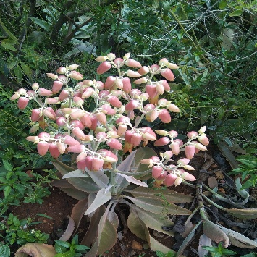
Figure 1 Kalanchoe pinnata

2.3 PHYTOCHEMICAL SCREENING
Preliminary phytochemical tests were carried out with all solvent fraction using standard procedure described by Siddiqi and Ali Sofwara and Sazda et al[13][14][15].

2.4 ANTIOXIDANT ASSAYS
2.4.1 FERRIC REDUCING ANTIOXIDANT POWER ASSAY (FRAP):
The reducing assay was based on the Fe ³⁺ to Fe ²⁺ reductive transformation according to Hue et al with modifications[16][17]. To 1mL of sample added 0.2mL of 0.2M phosphate buffer pH(6.6) and 1ml of 0.1% potassium ferricyanide. The mixture was incubated in water bath for 20 min at 50°C .Trichloroacetic acid (0.25ml) was added and centrifuged at 5000rpm for 10 minutes at room temperature. The supernatant was collected and added 0.2mL of deionized water and 0.1mL of 0.1% FeCl_{3.} The Fe ²⁺ was monitored by measuring the formation of Perl’s Prussian blue at 700nm.

2.4.2 PHOSPHOMOLYBDEUM ASSAY (TOTAL ANTIOXIDANT ASSAY):
The measurement of total antioxidant activity by phosphomolybdenum assay based on the reduction of Mo (VI) to Mo (V) by the compounds contained in the sample and subsequent formation of green phosphate Mo (V) complex at acid pH[18]. 0.1mL of the sample was combined with 1mLof the reagent (0.6mM Sulfuric acid, 28mM Sodium phosphate and 4mM Ammonium molybdate) and incubated at 95°C for 90 mins. Then the absorbance of the solution was measured at 695 nm (UV-Visible spectrophotometer, LT291) against blank after cooling to room temperature.
Total antioxidant capacity (%) = Absorbance of control-Absorbance of sample x 100
Absorbance of control

2.4.3 SUPEROXIDE DISMUTASE ACTIVITY (SOD):
Superoxide dismutase (SOD) acts as a primary defence against reactive oxygen species (ROS) by converting O²⁻ to O₂ and H₂O_{2.}The superoxide scavenging activity of the extract was determined by reduction in absorbance of superoxide nitro blue tetrazolium compound. Different concentration of the extract was mixed with 0.5ml phosphate buffer,50mM riboflavin,20mM PMS, and 0.1ml NBT sequentially. The reaction was commence by illumine the reaction mixture using florescent lamps. After for 20 minutes of incubation, the absorbance was measured at 560nm[19]. The SOD scavenging activity was determined by the following equation;
Scavenging activity = Control OD X 100
Treatment OD

2.5 THIN LAYER CHROMATOGRAPHY:
TLC studies was carried to identify the compounds in the mixture by comparing the Rf value of known compound with Rf of unknown compound. The extract was added as spots using capillary tube(20µl) on the one end of thin layer plate above 1cm .The plate was air dried, kept in a beaker containing methanol, acetic acid, formic acid and water in the ratio 3:1:1:0.5. The samples were allowed to run towards the end of the plate. The sheet was removed and allowed to air dry, incubated in iodine chamber for 5-10 minutes[20][21].
Calculated the R_{f} values using the given below;
R_{f} value = Distance moved by the solute
Distance moved by the solvent

2.6 UV-VISIBLE SPECTROSCOPY:
UV-visible spectrophotometric analysis was conducted on the K.pinnata extract using a UV-visible spectrophotometer, LT291 with a slit width of 100nm, using a 0.5nm absorbance at room temperature. The extract was examined under visible and UV light in the wavelength ranging from 200-800nm for proximate analysis[22].For UV-Visible analysis, the extract was centrifuged at 300rpm for 10 minutes and filtered through Whatman No filter paper.The distinctive peaks of the UV-Vis were detected, and their values were recorded. The wavelength ranges representing specific secondary metabolites.

2.7 FOURIER TRANSMISSION INFRARED SPECTROSCOPY:
Fourier transform infrared (FTIR) was used to identify the characteristic functional groups in the extract. It provides the information about the structure of a molecule could frequently be obtained from its absorption spectrum. A small quantity of the K.pinnata extract was kept in disc and was placed in a sample cup of a diffuse reflectance accessory. The IR spectrum was obtained using Shimadzu, infrared spectrometer. The peak values of the FTIR were recorded and analysed.

2.8 ANTIDIABETIC ACTIVITY:
The presence of zinc in the plants has a valuable role in the management of diabetes. The inhibitory effect of the extract on α-amylase and α-glucosidase was investigated in the plant extract as per the methodology proposed by Bagewadi et al[23].The enzymatic reaction includes increasing concentrations of extract and equal amounts of α-amylase (0.5 mg/ml) and buffered starch (1.0 %) prepared in phosphate buffer pH 7.0, the mixture was first incubated for 10 min at room temperature, further dinitrosalicylic acid (DNS) was added and absorbance was recorded at 405 nm. Similarly, 1.0 ml of the extract and 0.5 ml of the enzyme were used in a reaction to block α-glucosidase, which was carried out at room temperature for 10 min. by mixing in 0.5 ml of p-nitrophenyl-d-glucopyranoside (5.0 mM) and 1 ml of 0.1 M Na₂CO₃, the mixture was incubated for 10 min. and the reaction was stopped and the absorbance was recorded at 405 nm. Two enzyme controls were created and the inhibitory action against amylase and glucosidase was calculated by the following equation
Percentage of Inhibition (%) = Absorbance of control – Absorbance of sample X 100
Absorbance of control

3.0 RESULT AND DISCUSSION
3.1 PHYTOCHEMICAL SCREENING
The essential information’s regarding the chemical constituents are generally provided by the qualitative phytochemical screening of plant extracts. In the present study, qualitative tests for all four extracts showed significant indication about the presence of metabolites. Flavonoids, alkaloids, Quniones, Saponins, steroids were found to be present in the extracts of the leaves and reducing sugar could not be detected in the extract except chloroform solvent. While terpenes, phenol, proteins were not uniformally found in both the cases. These findings of phytochemicals were good enough to reflect its importance.
phytochemical | aqueous | ethanol | n-hexane | chloroform
Alkaloids | ++ | +++ | - | -
Flavonoids | ++ | +++ | - | -
Phenol | - | +++ | - | -
Sugar | - | - | - | ++
Terpenoids | - | - | - | -
Saponins | ++ | +++ | - | -
Quniones | + | + | - | -
Proteins | - | + | - | -
Steroids | - | ++ | - | -
Table 1: Qualitative phytochemicals analysis of K.pinnata in different solvent system

3.2 ANTIOXIDANT ASSAYS
From the phytochemical analysis of plant extracts, ethanol and aqueous extracts showed good results which leads to antioxidant and antidiabetic activity.
The Reducing Power assay were carried out for the aqueous and ethanol extracts of K.pinnata. The Reducing Power values of both extracts increased with increase in concentration when compared with the standard curve of ascorbic acid. (Table2) The Reducing values of plant extract of K.pinnata was tested against varied concentration and the absorbance increases with increase in concentration. FRAP value of aqueous extract is 76.87 mg/100g and that of ethanol extract is 144.05 mg/100g. The ethanol have a higher reducing power when compared with the aqueous extract. The findings of this study demonstrate a concentration dependent increase in absorbance value of the ethanolic extracts of K.pinnata depicts the ferric reducing power assay.
The phosphomolybdenum assay was based on the reduction of phosphomolybdate at 695nm.The aqueous and ethanol extract of K.pinnata were tested against varied concentration and found to have the increase in absorbance. The ethanol extract shows total antioxidant capacity of 612.25 mg/100g while aqueous extract shows 314.14 mg/100g when compared to the standard curve of ascorbic acid .The strong antioxidant activity of ethanol extract which was statistically analogous to that of ascorbic acid reveals strong antioxidants in this sample and this could be associated to presence of the high amounts of phenolic compounds.
The superoxide radicals generated from dissolved oxygen by PMS-NADH coupling can be measured by their ability to reduce NBT. The SOD activity assay results (Table 2) shows that the K.pinnata aqueous extract has the higher percent of enzyme activity (72.1 %) while the ethanol extract has comparatively low percent of inhibition at a range (17.16 %).This results suggests that radical scavenging effects is increased in the extract and the reference compound with increase in concentration, shows that plant is more potent to superoxide radical.

Plant Extract | FRAP (mg /100g) | TA Assay (mg /100g) | SOD( %of Inhibition)
Ethanol | 144.05 | 612.25 | 17.16
Aqueous | 76.87 | 314.14 | 72.1
Table 2: FRAP, TA and SOD of plant extracts

3.3 THIN LAYER CHROMATOGRAPHY
TLC profiling gives an impressive result that directing towards the presence of number of phytochemicals. The variation in R_{f} values of the phytochemicals provides a very important clue in understanding of their polarity and also helps in selection of appropriate solvent system for separation of pure compounds by Column Chromatography(Table3).The spots were visualised by exposure of the plates to ninhydrin at 254 nm and 365nm Fig.4,5,6. TLC profiling of plant extracts in different solvent system confirms the presence of diverse group of phytochemicals.
Sample Used | R_{f} value
Water  Spot 1 | 0.58
Ethanol  Spot 1  Spot 2 | 0.58  0.66
Table 3: R_{f} values of the Extracts

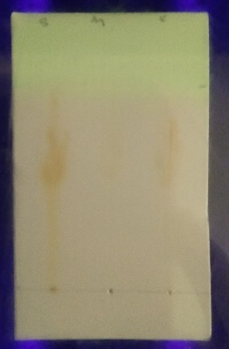
Fig.4. TLC at 254 and 365nm Fig.5.TLC at 254 nm Fig.6. TLC at 365nm

3.4 UV-VISIBLE SPECTROSCOPY:
The UV-Visible profile of the ethanol extract Fig. 7 of K.pinnata 200nm to 800nm due to broadness of distinctive peaks and proper baseline. This technique was used to detect the presence of the phytochemicals by identifying compounds containing π-bonds, lone pairs of electrons, σ-bonds, aromatic rings, and chromophores in the UV-Vis region on the electromagnetic spectrum ranging from 200nm to 800nm.
The UV-Visible profile revealed the peaks at 205, 230, 265, 275, 290, 390, 585 and 785nm.Various studies showed that the absorption band at 234–676 nm are characteristic for alkaloids, flavonoids, and phenolic compounds[24][25]where all peaks occur in this range. Therefore, this suggest the presence of secondary metabolites in the extract.
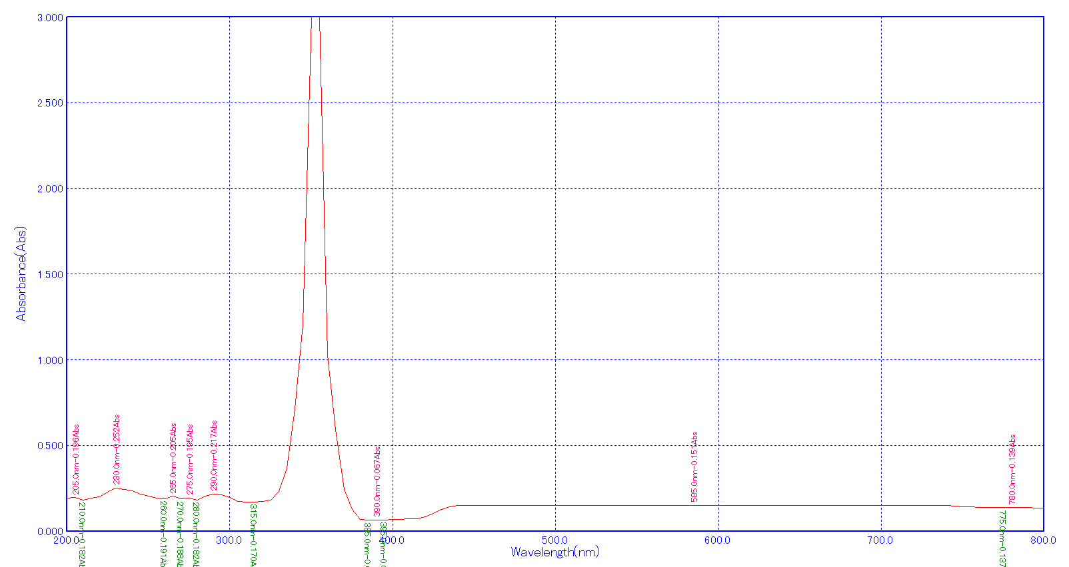
Fig. 7: UV-Visible Spectroscopy of the extract

3.5 FOURIER TRANSMISSION INFRARED SPECTROSCOPY:
Fourier Transmission Infrared Spectroscopy were taken to identify functional groups present in the K.pinnata, involved in this process region. The FT-IR spectra of the extract is shown in Fig.8. The corresponding peaks observed is represented in the Table 4
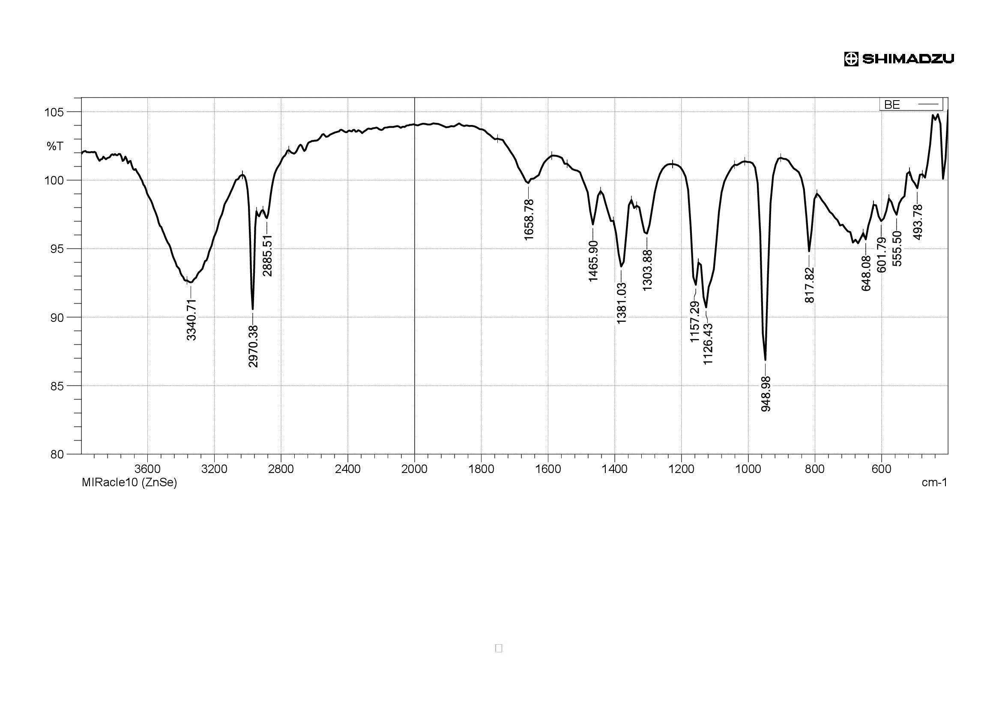
Fig.8: FTIR analysis of extract

Functional group | Intensity of Band | Frequency( cm⁻¹)
Hydroxyl group | Strong band | 3340 cm⁻¹ corresponds to alcoholic OH stretch
Alkyl group | Weak band | 2970 cm⁻¹ corresponds to C-H stretch
Alkene | Weak band | 1658 cm⁻¹ corresponds to C=C vibrations
Methylene group | Medium band | 1465 cm⁻¹ corresponds to CH₂ vibrations
Nitro group | Strong band | 1381 cm⁻¹ corresponds to NO₂ stretch
Halogen compound | Strong band | 1157 cm⁻¹ corresponds to C-F stretch
Silica group | Strong band | 948 cm⁻¹ corresponds to condensation OH stretching vibration.
Table 4: FT-IR spectral data of the Kalanchoe pinnata

3.6 ANTIDIABETIC ACTIVITY:
Alpha-amylase and alpha-glucosidase enzymes in the digestive system are essential for the metabolism of starch, glycogen, and disaccharides. The synergistic tests were conducted to determine α -amylase and α-glucosidase inhibitory activities and are reported in Table 5. K.pinnata contains the compounds that can bind to the enzyme and inhibit their activity, whereby they can reduce the level of glucose that is freed into the system. The inhibitory effect of aqueous extract was found to be higher percent of inhibition 62 % and 81 % respectively for both enzymes while the ethanol extract showed only 59% and 42% inhibitory percent which makes the aqueous extract of K.pinnata effective. Alpha-glucosidase and alpha-amylase inhibition is a medicinal strategy employed in the treatment of DM by inhibiting these enzymes, the absorption of glucose is slowed down and the digestion of sugars and carbohydrates is delayed[26] In this current study, it is expected that phytoconstituents derived from K. pinnata will exhibit inhibitory effects on alpha-amylase and alpha-glucosidase enzymes.

Plant Extract | α-amylase (%) | α-glucosidase (%)
Aqueous | 62.61 | 81.3
Ethanol | 59.3 | 42.8
Table 5: α-amylase and α-glucosidase activity

4.0 CONCLUSION:
As a presumption from the analysis, Kalanchoe pinnata, is a heavenly herb that exhibit a wide range of potential pharmacological activities that involves the treatment of various disease to mankind. From the different characterization techniques, we conclude that the various biomolecules such as alkaloids, flavonoids, steroids, quniones present in the various extract of K.pinnata. The two extracts were investigated for the further studies in which ethanol extract shows better results for the Ferric reducing Assay and Total antioxidant assay. Aqueous extract provide insight into K.pinnata’s promising potential antidiabetic properties inhibiting alpha-amylase and alpha-glucosidase enzymes. Further research is recommended to explore the potential antioxidant and antidiabetic properties of the extract.

5.0 REFERENCES:
- WHO expert consultation. Report of the expert committee on the diagnosis and classification of diabetes mellitus. DiabetesCare 2002; 25: 5–20.
- Supratman U, Fujita T, Akiyama K, Hayashi H, Murakami A& Sakai H, Journal Biosci, Biotechnol Biochem (2001) 947.
- Waqar M A & Shaukat S, J Chem Soc Pakistan, 28 (2006) 391.
- Bellamy L., Casas J. P. Hingorani, A. D. Williams D. Type 2 diabetes mellitus after gestational diabetes: a systematic review and meta-analysis. Lancet 2009; 373: 1773–1779.Doi: 10.1016/S0140-6736(09)60731-5.
- WHO. Global report on diabetes 2016; Geneva: WHO.
- Bhandari MR, Jong-Anurakkun N, Hong G, Kawabata J. α-Glucosidase and α-amylase inhibitory activities of nepalese medicinal herb pakhanbhed (Bergenia ciliata, Haw.). Food Chem. (2008) 106:247–52. Doi: 10.1016/j.foodchem.2007.05.077
- Alarcon-Aguilara FJ, Roman-Ramos R, Perez-Gutierrez S, Aguilar-Contreras A, Contreras-Weber CC, Flores-Saenz JL.Study of the anti-hyperglycemic effect of plants used as antidiabetics. Journal of Ethnopharmacology 1998; 61: 101-110.
- Bhavsar S, Dhru B, Zaveri M, Chandel D. A comparative pharmacognostical and phytochemical analysis of Kalanchoe pinnata(Lam.) Pers. leaf extracts. J Pharmacogn Phytochem 2018; 7:1519-27.
- Fürer K, Simões-Wüst A, Von Mandach, U, Hamburger M, Potterat O. Bryophyllum pinnatumand Related Species Used in Anthroposophic Medicine: constituents, pharmacological activities, and clinical efficacy. Planta Medica. 2016. 82(11–12):930–941.DOI: 10.1055 / s-0042-106727
- Pattewar SV. Kalanchoe pinnata: Phytochemical and Pharmacological Profile. International Journal of Pharmaceutical Sciences and Research. 2012; 3(4):993–1000. DOI: http://dx.doi.org/10.13040/IJPSR.0975-8232.3(4).993-00
- El Abdellaoui S, Destandau E, Toribio A, Elfakir C, Lafosse M, Renimel I,Andre P, Cancellieri P, Landemarre L. 2010. Bioactive molecules in Kalanchoe pinnata leaves: extraction, purification, and identification. Anal Bioanal Chem. 398:1329–1338.
- Kolodziejczyk-Czepas J, Stochmal A. 2017. Bufadienolides of Kalanchoe species: an overview of chemical structure, biological activity and prospects for pharmacological use. Phytochem Rev. 16:1155–1171.
- Siddiqui AA and Ali M, Practical Pharmaceutical Chemistry, IST Edition, CBS Publishers and distributors, New Delhi, 126-131 (1997).
- Sofowora A, Medicinal plants and traditional medicine in Africa, John Wiley and Sons Ltd: New York, (1993).
- Sazada S,Verma A, Rather AA, Jabeen F, and Meghvansi MK, Preliminar phytochemicals analysis of some important medicinal and aromatic plants, Adv. in Biol. Res., 3: 188-195 (2009).
- Hue, S. M., Boyce, A. N., and Somasundram, C. (2012). Antioxidant activity, phenolic and flavonoid contents in the leaves of different varieties of sweet potato (Ipomoea batatas). Aust. J. Crop Sci. 6, 375–380.
- Benzie I.F.F., Strain J.J. The ferric reducing ability of plasma (FRAP) as a measure of Antioxidant Power: The FRAP assay. Anal. Biochem. 1996; 239: 70–76.
- Prieto P, Pineda M, Aguilar M. Spectrophotometric quantitation of antioxidant capacity through the formation of a phosphomolybdenum complex: Specific application to the determination of Vitamin E.Anal Biochem 1999; 269:337-41. Doi: 10.1006/abio.1999.4019, PMID 10222007.
- Quazi Majaz*, Molvi Khurshid, Sayyed Nazim, Khan Rahil and Shikh Siraj, (2011). Evaluation of antioxidant activity of Kalanchoe pinnata roots. International Journal of Research in Ayurveda and Pharmacy, vol 2(6): 1772-1775.
- Shahverdi A R, Abdolpour F, Monsef-Esfahani H R, Farsam H A. TLC bioautographic assay for the detection of nitrofurantoin resistance reversal compound. J Chromatogr B. 2007;850:528–530.
- A. Das Talukdar, M. Dutta Choudhury, M.Chakraborty, B.K. Dutta, Phytochemical screening and TLC profiling of plant extracts of Cyatheagigantea (Wall. Ex. Hook.) Haltt. And Cyathea brunoniana. Wall. ex. Hook.(Cl. &amp; Bak.), Biological and Environmental Science, 5(1),2010; 70-74.
- C. Karpagasundari and S. Kulothungan, Journal of Pharmacognosy and Phytochemistry, 2014, 3(4), 196-201
- Bagewadi, Z.K., Muddapur, U.M., Madiwal, S.S., Mulla, S.I., Khan, A., 2019. Biochemical and enzyme inhibitory attributes of methanolic leaf extract of Datura inoxia Mill. Environ. Sustain. 2, 75–87.
- T. K. Patle, K. Shrivas, R. Kurrey, S. Upadhyay, R. Jangde, and R. Chauhan, “Phytochemical screening and determination of phenolics and flavonoids in Dillenia pentagyna using UV-vis and FTIR spectroscopy,” Spectrochimica Acta Part A: Molecular and Biomolecular Spectroscopy, vol. 242, Article ID 118717, 2020.
- C. Karpagasundari and S. Kulothungan, “Analysis of bioactive compounds in Physalis minima leaves using GC MS, HPLC, UV-VIS and FTIR techniques,” Journal of Pharmacognosy and Phytochemistry, vol. 3, no. 4, pp. 196–201, 2014.
- Patil, V.S., Deshpande, S.H., Harish, D.R., Patil, A.S., Virge, R., Nandy, S., Roy, S., 2020.Gene set enrichment analysis, network pharmacology and in silico docking approachto understand the molecular mechanism of traditional medicines for the treatment ofdiabetes mellitus. J. Proteins Proteomics 11, 297–310. https://link.springer.com/aticle/10.1007/s42485-020-00049-4.

